Susceptibility to change analysis for the city of San Marcos, TX

Authors
Jorge Morales- Project Manager, GIS Analyst
Thomas Middleton- GIS Analyst
Timothy Szpakowski- GIS Analyst

Prepared for:
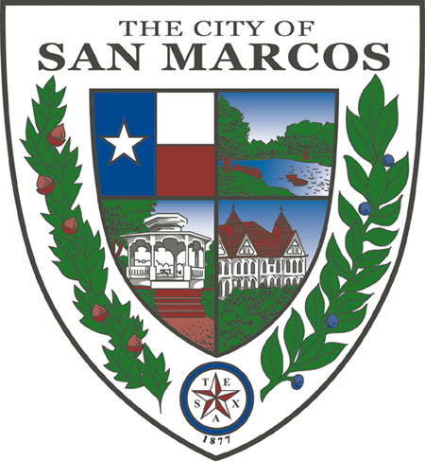

Prepared by: Aggiornamento
December 2, 2017

Table of Contents
1. Introduction 3
1.1 Summary 3
1.2 Problem Statement and Purpose 3
1.3 Scope 4
2. Literature Review 4
3. Data 5
4. Methods 7
4.1 Methodology- City Wide Analysis 7
4.2 Methodology- Neighborhood Character Study 10
5. Results 11
5.1 City wide results 11
5.2 Neighborhood Character Study Results 13
6. Limitations 16
7. Conclusion 17
8. References 18
9. Appendix A 19

Abstract: This paper looks at areas that are susceptible to be redeveloped or developed in the City of San Marcos. Using a weighted sum analysis, a total of six factors were evaluated. Owner occupancy, Walk scores, Historic Districts, Zoning, Residential Concerns (comments), and Land to Improvement ratios. In addition, an in depth neighborhood character study was performed in the Heritage area. The results indicated that a small portion of the entire city is highly susceptible to change. Majority of the total area in these neighborhoods met most of the factors that were analyzed in this report. In addition, 75% of the Heritage neighborhood is included among these areas that have a high probability.
Keywords: San Marcos, TX, GIS, Susceptibility, Urban Development, Texas State University
1. Introduction
1.1 Summary
In 2015, the U.S Census recognized the City of San Marcos (COSM) as the fastest growing city in the country for the third year in a row. (U.S Census) Like any successful growing city, guiding land development is crucial. This semester, Aggiornamento worked alongside the City of San Marcos, Planning and Development Service, to conduct a citywide susceptibility to change analysis to provide insight on land use trends and to identify areas that have a higher redevelopment probability. This analysis is an important tool that will assist with the city's plan to effectively manage growth. In addition, a detailed survey of current land use within the Heritage neighborhood was conducted to better understand what specific locations are susceptible to change, and to gain insight into characteristics that give this neighborhood its identity.

1.2 Problem Statement and Purpose
The results of this project serve as indicators to identify areas that have a high probability to be redeveloped versus those that are stable. Identifying these areas, allows the city to guide development and redevelopment projects in such a way that the goals of the preferred scenario are still met. One of these goals, is to ensure that some neighborhoods maintain their existing character. The survey conducted in the Heritage neighborhood, provides a detailed understanding of areas within this part of the city that may be developed or redeveloped in the future based on correlations between factors such as owner occupancy and property values. In addition to this, comments made by residents of the neighborhood were analyzed as these provide insight to what type of development is wanted by the public. This information, can then be used as a tool, that will help manage proposed projects in this area in such a way that guidelines set by the public are still followed. It is our goal, was to provide the City of San Marcos with a product that will benefit in achieving their vision of how they want the city to grow.

1.3 Scope
The study area of this project, covered the entire City of San Marcos. The neighborhood character study focused specifically on the Heritage neighborhood (Figure A.1), which is one of six neighborhood characters that are composed of 32 neighborhoods designated by the Council of Neighborhood Associations (CONA).
The Heritage Neighborhood that our client wanted us to analyze consist of four different CONA neighborhoods Heritage, Dunbar, East Guadalupe, and Victory Gardens. This area is located south of downtown covering a mile along Hopkins Street stretches east towards I-35, and reaches north to Riverside Drive. All project content and deliverables were conducted during the Fall 2017 Semester, September 2017 through December 2017, with the final project submitted on December 4th.

2. Literature Review
San Marcos, TX is one of the fastest growing cities in the United States. Located half way between two of Texas largest cities Austin and San Antonio, it is no surprise that this small city, which is also home to Texas State University, has a current population of about 61,000. According to the U.S census between 2013-2015, San Marcos city was the recognized as the fastest growing city for three consecutive years.
Like many growing cities, it is common to see redevelopment occur in order to accommodate for the growing population. The concentration of this paper is to explore the methods that have previously been employed to most accurately assess change on large scale neighborhoods using on multiple factors. The over-all goal is to apply the most specialized process to the task of evaluating both the entire city and the Heritage neighborhood to locate the areas that are most susceptible to change.
Susceptibility to change analysis are very common as they help identify areas that need to be focused on depending on what the goal is. An example of this type of analysis was conducted in St. Charles, IL, to focus on development within the downtown area in order to support their community's vision. In the case of St. Charles, high probability for change is described as a parcel in which “redevelopment is actively pursued” where as having low probability was described as parcels where “change is largely dependent on the owner’s interest in making the change” (Downtown St. Charles Strategy Plan). In the City of San Marcos, we can define susceptibility in a similar form however, one difference in the study area is that San Marcos is described as a “college town”. Because of this, it home to students attending Texas State University during the academic year. This results in far more development for multi residential housing. While an individual owner in the City of San Marcos may not necessarily choose to pursue change by redeveloping his home to house students, it may be more reasonable to imagine that he along, with neighboring homes, may be bought out to make room for these kinds of projects. As a method to prevent large projects like large student housing projects to come into small residential neighborhoods, the city of San Marcos has gotten the community involved and have now constructed a preferred scenario map. This map highlights 3 levels of intensity for urbanization broken it low, medium, and high categories. Areas with low intensity are representative of single family houses, while medium and high intensity are large residential apartments, condos, and 4+ story buildings (Figure A2, Appendix A).

3. Data
Sources for our data include the City of San Marcos, Hays County Appraisal District (Hays CAD), and FEMA (Table 1). Initially we were provided with an ArcMap package by our client containing data for the city of San Marcos, which included road networks, zoning data, parcel data, residential comments, and neighborhood boundaries. In addition, our clients included data gathered from the Hays CAD that included property values, improvement values, and exemption status. This data was important for our analysis, as we used property and improvement values to obtain a land-to-improvement ratio, exemption status to determine owner occupancy, neighborhood boundaries for zoning and walk scores, which were all factors in our analysis. The accuracy of this data was checked on the Hays CAD website and indicated that the two sources matched.
To conduct our analysis, we tried to use the most recent data. However, many of our parcels contained no data for 2016, to mitigate gaps in our data we combined the 2015 data and 2016, both which were provided by our client and were obtained from Hays CAD. We took our clients professional input into consideration to do this as they confirmed that in many cases there is not much of a difference in property and improvement values within a short amount of time such as a year.
Other data such as neighborhood boundaries and residential comments, allowed us to better conduct our character study, as we were able to get insight into what concerns residents in the city have. The zoning data allowed us to identify areas that are in transition as they have a large mixture of different zoning codes. We also wanted to demonstrate what areas within the Heritage boundary are in a flood zone, to do this we collected flood zone data from FEMA.
Because the weighted overlay only works with raster data, the data for our factors had to be converted into raster format, this conversion used a cell size of 50 feet as the output.
Table 1
Entity | Attributes | Spatial Object | Source
Roads | Street Name | Line | COSM
Parcel | Address, Land/Improvement Values, Owner occupancy | Polygon | COSM/Hays CAD
Historic Districts | General Area | Polygon | COSM
Zoning | Zoning Codes | Polygon | COSM
Neighborhood Character Study | Comments, General Area | Point | COSM
Flood Damage | Area | Polygon | COSM
Flood plains | Area | Polygon | FEMA

4. Methods
4.1 Methodology- City Wide Analysis
To conduct our analysis, we used an overlay tool, specifically weighted sum. This tool allowed us to create several layers, each one corresponding to a factor that can influence a location to be developed or redeveloped. The tool then adds the overlaying values of the layers from the input. It also allows for weights to be assigned to each layer, this is important as it helps to take into consideration the fact that some factors may have a significant influence over an area to change or prevent it from changing, while other factors don’t have as much influence.
We first reviewed the data we were provided to determine what data we are missing. To properly conduct our analysis, we had to verify some information and check for accuracy. This was done by comparing data from a random sample of 30 parcels from the data we were provided to the data listed on the Hays CAD webpage. This indicated that the data was accurate and was good to use.
After our data was obtained and organized, we created layers for each factor that corresponds to its influence on an area regarding development and redevelopment. We looked at six different factors: historic districts, land to improvement ratios, neighborhood walk scores, owner occupancy, zoning, and public comments.
Parcels located in historic districts will be the least susceptible to change as they are protected. Due to the size of this city we looked at walks scores instead of focusing of accessibility to road, walk scores ranged from 0 to 100 based on an areas location and objects that are around it, such as other neighborhoods, commercial areas, roads, ect. Owner occupancy was determined by looking at Hays CAD which indicate areas that have the Homestead Exemption (HS), as areas that have more rental properties are much more attractive to investors which can lead to change. Regarding comments, areas that have more comments also have more public concern, this can lead to the area being susceptible to change. Areas that have a mix of zoning are also more susceptible to change.
The land to improvement ratios were determined by dividing the improvement values by the total land market value. This was done following a similar analysis conducted in the city of Austin, the theory behind this factor is that “land owners will seek to maximize their investment in the land by developing or redeveloping when the value of the improvement is less than the land” (Rouse, 2010). We then standardized the values by dividing the min value (.00008) by the max value (90.15) and then subtracted the result by the min. However, there were a few values that were higher, but 90.15 was determined to be the max value we would use the as the four other values above this max were outliers as that range from 143.10 to 601.26, those values were then standardized accordingly.
The weighted sum tool used for this analysis only accepts integer values, to conduct our analysis we had to assign each parcel respective integer values ranging from 1 to 10 based on the factor looked at. Initially we intended to begin our rank at the 0 value, but realized the tool we were using for our analysis read 0 values as no data and excluded them in the results.
A value of 1 was assigned to locations in which a factor is the least likely to influence the probability for change to occur, 5 was reserved for mid-level influence, and a ranking of 10 was assigned to areas that have the highest influence for change to occur. All other values in between, range based on the factor being looked at. For some dichotomous factors, such as owner occupancy and historic district, the values could only be 1 or 10.
To assign our weights properly, literature material from previous analysis conducted in other cities was taken into consideration. In addition, we discussed these factors with our client, to take their professional opinion into consideration.
After every layer was created, appropriately ranked, and converted to raster using the ranked values, we perform our weighted sum analysis. This analysis took locations and summed up all the ranks across the different layers of factors which resulted in a summed total. The summed total is generated while taking into consideration the different weights assigned to each factor.
Since the parcels in the heritage districts prevent change from occur this factor was assigned a weight of 7, with a rank of 1 assigned to factors that are in the district and 10 for those that are not. Because this is a dichotomous factor, parcels that rank 10 and are susceptible to change will be influenced equally.
The owner occupancy factor and land-improvement ratio were both given a weight of 4. Owner occupancy was also a dichotomous factor, however for the land-improvement ratio three ranks were used. For values in which the improvement value was below the value of the land, a rank of 10 was given, mid values ranking in the middle were given a rank of 5, and values in which land value significantly exceeded the improvement values were given a rank of 10.
The final three factors were classified using the CONA boundaries. For the comments factor, the number of comments within each neighborhood were summed up. (Table 2) The maximum number of comments was 152 while the minimum was 0. Starting from the minimum value, a rank value increased for every 15 comments, this factor was then given a weight of 2.
The number of different zoning codes within a neighborhood boundary was also counted. The max value was 19 while the minimum was 2. Similar to the comments, starting from the minimum value, a rank value increased for every additional pair of different zone code in the boundary, this factor was then given a weight of 3.

Table 2.
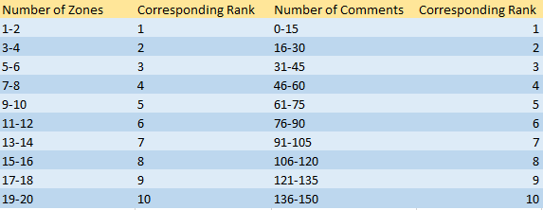
Finally, the walk score of the CONA neighborhoods was collected utilizing the website (walkscore.com). While majority of the neighborhoods had walk scores, some did not. We took the same concept applied by the website to generate the score by evaluating criteria’s such proximity to business clusters, size of the area, and relative distance from the San Marcos central area. Judging these values, we compared to surrounding areas and similar neighborhoods to adjust the number accordingly.
Using natural breaks, the final results from the analysis include were divided in to three classes, low probability, potential exist, high probability.

4.2 Methodology- Neighborhood Character Study
After conducting the city-wide analysis, we focused our attention on the heritage neighborhood to conduct an in-depth character study of the area. To conduct this study, we went out to the neighborhoods and took photographs of areas that appear to be susceptible to redevelopment.
In addition, we analyzed several neighborhood traits such as land use trends, areas with areas located within flooding zones, property values, architectural patterns and other traits. We also compared our results of the city-wide analysis to specifically focus on areas with high probability to change within the boundary of the Heritage neighborhood. Residential comments within the data provided by the City, were analyzed to construct a descriptive summary of what residents would like to see in terms of future development. This information allowed us to create several different maps that help us visually see patterns and trends. We also took this data and compiled it to create a portfolio that can be used to help an audience get a better understanding of the Heritage neighborhood character.

5. Results
5.1 City wide results
32 different CONA neighborhoods were analyzed using the results obtained using the weighted sum analysis. While we did have three different classes for our results, we conclude that areas that fall in the middle classification may lean towards the next classification surrounding it. For example, if an area is in the middle classification and is surrounded by highly susceptible areas, then those middle-classed areas will be more susceptible to change, and vice versa if they are surrounded by low susceptible areas.
The results indicate that in 7 of the 32 neighborhoods, majority of their areas are susceptible to change. The most susceptible neighborhoods are Blanco Gardens, East Guadalupe, Hunters Hill, Dunbar, Sunset Acres, and Victory Gardens, and Sessom Creek. The results also indicate that 9 of the 32 neighborhoods have an about an equal amount of area that falls into all three classes, and 16 remaining neighborhoods contain majority of their areas in the low probability class range. Figure

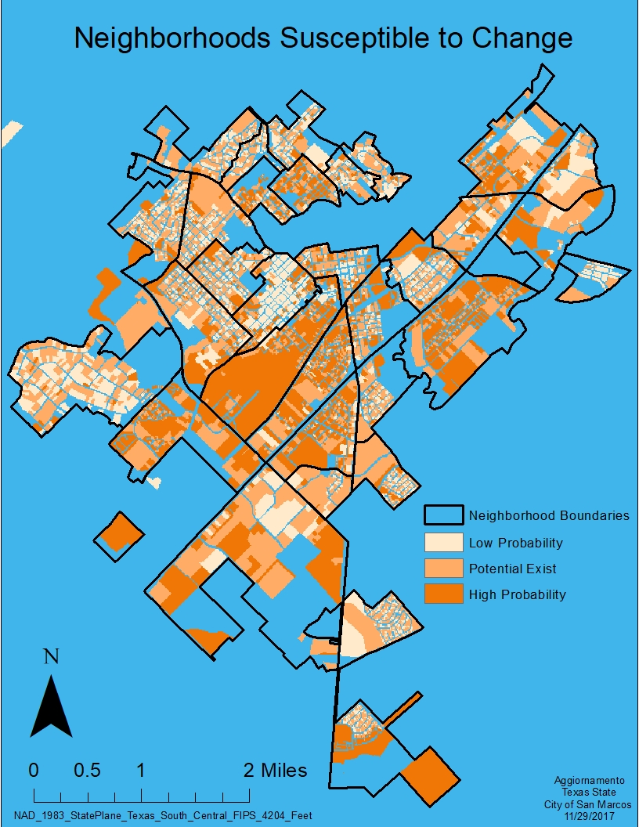
Figure 1. Susceptibility in San Marcos, TX categorized by CONA Boundaries

5.2 Heritage character study results.
Our in-depth neighborhood character study, indicates that while the four CONA neighborhoods within the heritage area have some distinctive characteristics, they also contain distinctive traits.

Heritage
The Heritage neighborhood is located on the Southeastern side of the downtown San Marcos area. It contains commercial businesses that are in professional buildings that are in high concentration areas, in which businesses are run out of converted houses that spread into residential areas. Other than a sign in the front yard there is very little to set them apart from the surrounding houses.
The Heritage area also contains much of the historic district of San Marcos, as 6 out of the 7 historic districts are in this area. There is also a large concentration of houses on the National Register for Historic Places, and a fair number that are over a hundred years old. There are examples of several distinct architectural styles such as houses constructed in 1901 that have Gothic Victorian architectural style with Queen Anne stylistic influences.
The area is easily accessible by a main artery of San Marcos, Guadalupe Street, and by Hunter road. While there are no major open spaces in this neighborhood, it does contain wide parkway style roads with sidewalks that allow for accessible walking to the downtown area adjacent to the sprawling residential area.

Victory Gardens
The Victory Gardens is one of two CONA neighborhoods in this area that is located along I-32. Several small businesses are located within the neighborhood. While these businesses are off the beaten paths from the main San Marcos roadways, they indicative a rich community culture that is becoming rarer in communities. Unfortunately, some of these businesses are closed or are waiting to be reopened, and indicates flexibility in future planning and community infrastructure. Along Guadalupe Street is a mix of zoning allowing for businesses to neighbor residential parcels, this may be a pressure for the continued influx of businesses filling in the transitional parcels.
Majority of this area was built in the early 1950s and on; there are several examples of parcels that are newer developments within the neighborhood, as well as parcels that have most likely been rebuilt due to being obviously newer and of a different style than the neighbors surrounding it. Unlike the architecture in the CONA heritage neighborhood, most of the houses in the area are the original structures from the 1950’s and reflect the previous style of a smaller house with a small fenced in front and back yard.
While the proximity to I-35 provides this area with access to a major transportation network, internally it contains a train crossing that intersects one of the main roadways which can restrict access within the area.
Unlike the Heritage neighborhood, Victory Gardens contains more open space with several neighborhood parks, as well as undeveloped parcels of land scattered throughout the area.

Dunbar
Dunbar rest in between the Heritage, Victory Gardens. This places it South of the downtown area, and makes it immediately accessible by a single major roadway. It contains multiple parks, large shade providing oak trees, and much of the same style and era of development as its sister neighborhood, Victory Gardens. There is evidence of parcels having been redeveloped in recent years alongside the original homes built there. While it shares major characteristics with the Victory Gardens, as they share a close time frame of construction, it serves as an architectural transition zone between Victory Gardens and Heritage, due to the parcels that have been redeveloped.
Due to its location between Heritage and Victory Gardens, Dunbar is only directly accessible from the highway by using Wonder World Road, otherwise secondary roads can be used to gain access.

East Guadalupe
Located directly adjacent to Guadalupe Street, this is the second neighborhood in this character study that is next to I-35, allowing the area to be accessible and has a substantial grid of roads that interconnect the area. It also contains access to a second major artery of the city, through the connection provided by LBJ Drive. Guadalupe Street, which is a major road in this area, is composed primarily of commercial businesses, stores, and several San Marcos staple restaurants. While most of the area is used by businesses, there are a few small clusters of houses and a large pocket of residential streets in the neighborhood. Similar to Victory Gardens, there are several large parks, including a sports complex adjoining the river in the far North side of the neighborhood which is not seen in the other four CONA neighborhoods.
5.3 Susceptibility results in Heritage.
Three of the seven neighborhoods that resulted in majority of their area to have high probability to change are in this character study area. These neighborhoods are East Guadalupe, Dunbar, and Victory Gardens.
Analyzing each factor individually we have some proposed ideas that help understand the reason behind these results. (Figure 2) Dunbar contains a high number of comments resulting in more public concern to drive change. All three neighborhoods contain parcels in which land value exceeds the most current improvement values, this results in more interest in investors to take advantage of this area. While all three areas contain majority of parcels with the HS exemption, there are a few properties that do not have this exemption. With rental properties present investors will also be able to redevelop. These areas have very close proximity to I-35 and major roads like Guadalupe St., which are areas of high concentration for businesses. This results in these three areas having a high walk score, which more appealing for investors looking to develop and redevelop. In addition, Victory Garden and Dunbar contain fairly high number of different zoning districts.

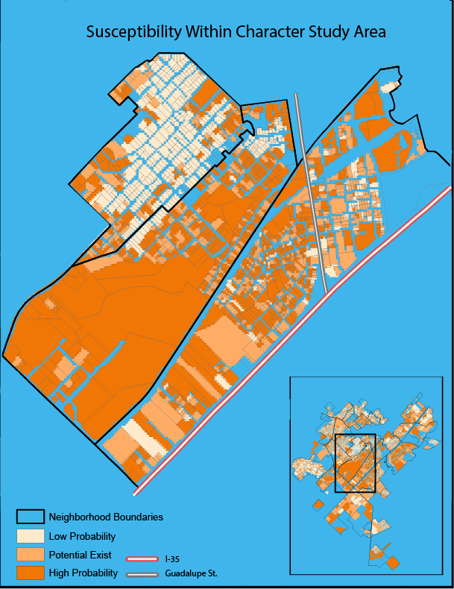
Figure 2. Susceptibility within the Heritage character study area
6. Limitations
The major limitation to this analysis was not having data in certain factors for some parcels. For example, zoning areas were not mapped out in some areas where we had parcel information for. This created gaps in our final result, because areas that are missing data for one factor layer, will be completely excluded from the results.
A second limitation, comes from the comment factor, the theory behind this factor is that areas in which more concern is present will result in higher susceptibility. However, our client mentioned that when this information was collected, some neighborhoods had no representatives show up. This would mean that some neighbors may be misrepresented in our data. To mitigate this possible misrepresentation, this factor was given one of the lower weights.
A final limitation to take into consideration, is regarding the number of different zoning codes in an area. Based on the modifiable areal unit problem (MAUP), the results of this factor have a higher chance for bias to be introduced based on the size of the area. Had this factor been analyzed using larger or smaller blocks the results may have varied. Once again to mitigate this limitation this factor was not assigned a highly significant weight.

7. Conclusion
The city of San Marcos has potential to continue to grow as it is influenced by factors such as Texas State University and proximity to two major Texas cities. While there appears to be room for areas to supply the demand of future changes that may occur, it is important for the city to plan accordingly. These results illustrate areas that can be focused on to better manage development and redevelopment. However, due to the factors that were into consideration and some of the limitations, it would be wise to continue to run these kinds of analysis introducing new factors and more data to compare results. This allows for more in-depth analysis that may serve better use. We hope that these results not only meet our client’s expectations and needs, but set forth a foundation for future analyst to take this model and make it better.

8. References

- "Downtown St. Charles Strategy Plan." Nov. & dec., 2000. Accessed October 20, 2017. https://www.stcharlesil.gov/sites/default/files/documents/strategic_planning/cp-appendix1pdf.pdf.
- "Get your Walk Score." Walk Score. Accessed November 20th, 2017. https://www.walkscore.com/.
- Rouse, David, Dobshinky, Andrew, e-mail message to Garner Stroll, February 16, 2010
- “South, West Have Fastest-Growing Cities, Census Bureau Reports; Three of Top 10 are in Texas Capital Area.” Census.gov, 5 May 2014, www.census.gov/newsroom/press-releases/2014/cb14-89.html. Accessed 21 Sept. 2017

9. Appendix A
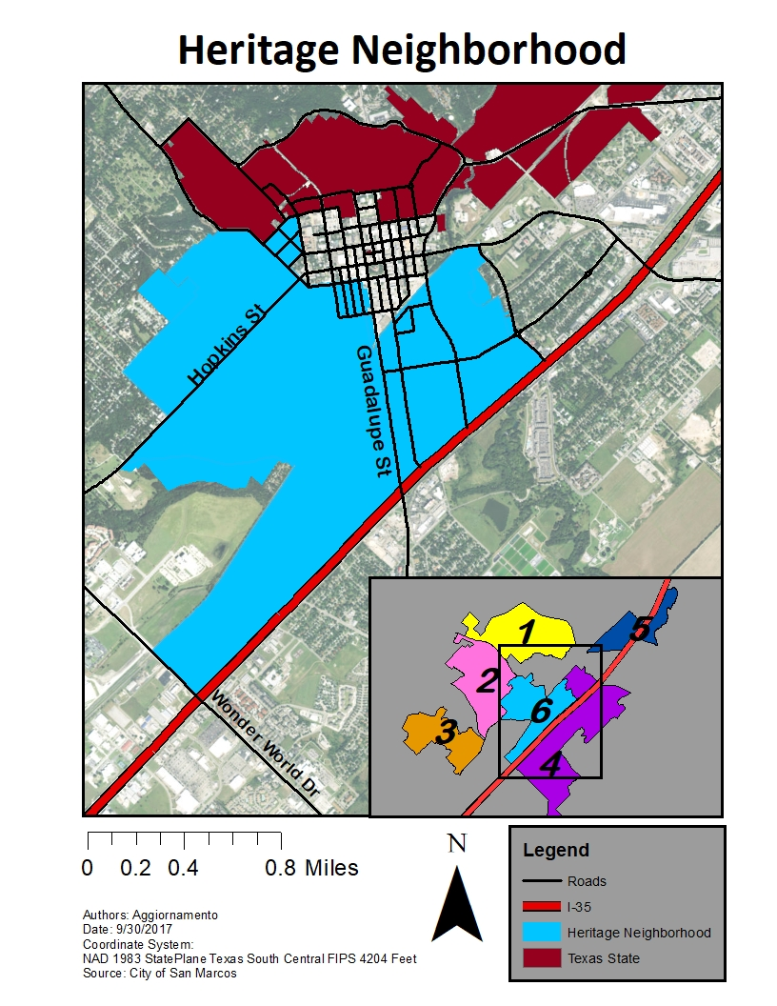
Figure A1: Reference Map of Heritage Neighborhood with inset showing the 6 neighborhoods.

Name | Contribution
Jorge Morales | Organized data, ran overlay analysis, created city wide map, created poster, and wrote final report.
Timothy Szpakowski | Created character study maps and website.
Thomas Middleton | Wrote neighborhood character study report and photographed study area.

Meta Data (File) | Descrpition
Final CONA (Council of Neighborhood Associations) edited data | additional data including neighborhood walkscores, number of public concerns within each boundary, and number of differnt zoning codes in the areas.
Final_Parcel_Data | This data was created using data provided by the city of San Marcos. It contains attributes that correspond to the factors used in our susceptibility to change analysis. They also contain the classifed ranks used to run the overlay analysis.

